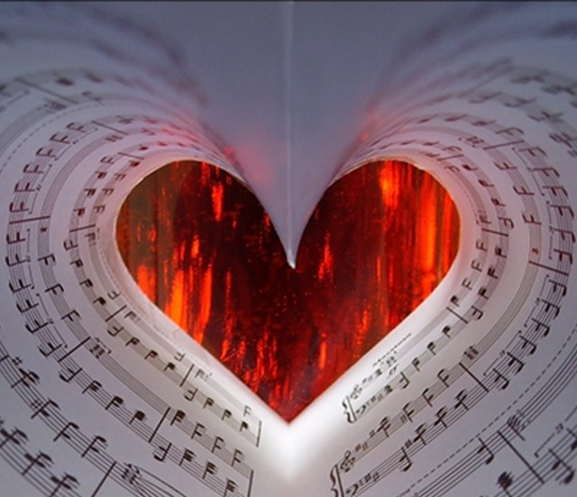

Teaching Musical Artistry and Expression©
By Vickie J. Maybury

- Music is sound moving in and out of silence. Music and art are not a paint-by-number exercise. Attacks and releases can be addressed from an artistic side. Kinesthetics, creating visual pictures, and the use of colors and textures play a huge role in teaching musical artistry.

- Don’t sing square notes. All notes should have life and be energized with nuance and inflection. Singing notes and rhythm patterns precisely produce characteristic sounds that are sterile with no attached meaning.

- Notes remain trivial until they are animated with feeling and spirit. Musical expression is found behind the notes. (There’s actually nothing “behind the notes”—only you as a singer.) Your personal musical expression is created by your musical imagination and personality—your unique style.

- Our singing instrument has no personal intelligence. It is when we ask our whole brain to become involved that our singing instrument takes on intelligence and meaning. If you can’t say it, you can’t sing it. Many times students have problems understanding rhythm patterns because they weren’t asked to speak them.

*Adapted from The Musical Mind of the Creative Director by Edward S. Lisk

