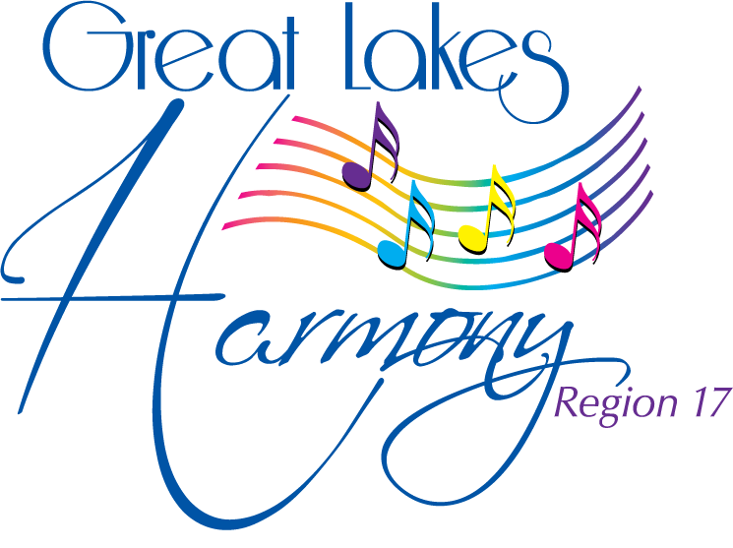
MUSIC SCHOLARSHIP AWARD OVERVIEW

GREAT LAKES HARMONY REGION #17

DESCRIPTION

Region #17 is pleased to offer a $1,000 scholarship to a woman attending an accredited college or university who is studying in a music-related field. The award is administered through our Regional Management Team who reviews all applications, evaluates candidates using established selection criteria and selects the recipient. The award is presented during the Annual Spring Convention weekend.

ELIGIBILITY REQUIREMENTS

To be eligible for consideration for this scholarship, the student must:

1. Be a woman who is a member of Great Lakes Harmony Region 17 Sweet Adelines
International – OR – be related to a current member or chorus director of Region 17.

2. Be entering sophomore year or above in an accredited college or university.

3. Be pursuing a degree with a major or minor in vocal music or a music related field
(performance or education).

4. Preference will be given to those who have not previously received this award.

APPLICATION PROCEDURE

1. Completed application form and all supplemental material must be received no later than
March 1, 2018 via email: Clara.48@aol.com

2. All supplemental materials must be single-sided copy on 8-1/2 x 11 size paper.

3. The following materials MUST accompany the application:

- Two (2) letters of recommendation, one from an educator who is familiar with the applicants musical ability.
- List of relevant academic achievements.
- List of extra-curricular and civic activities.

The Music Scholarship Application is attached.
Please announce or post this information so that all members are aware of this opportunity for themselves or a family member!

Applications must be RECEIVED by the Scholarship Coordinator by March 1, 2018 via email: Clara.48@aol.com

If no qualified applications are received by the deadline no scholarship will be awarded.

2
MUSIC SCHOLARSHIP AWARD APPLICATION

GREAT LAKES HARMONY REGION #17

To be completed by scholarship applicant:

Name:
Address:
Street | City |  | State | Zip Code
Phone: |  | Email:
Name of current college/university:
Major: |  | Minor:
Year: |  | GPA:
Major focus in the music field:
________________________________________________________________________________________
________________________________________________________________________________________
________________________________________________________________________________________

What are your long term goals upon receipt of your degree:
________________________________________________________________________________________
________________________________________________________________________________________
________________________________________________________________________________________

What is your relationship to the person making this nomination:
____________________________________________________________________________
____________________________________________________________________________

To be completed by Region 17 relative, member or director:

Chapter Affiliation:

Phone: | Email:
Reasons for nominating/ recommending this applicant:
________________________________________________________________________________________
________________________________________________________________________________________
________________________________________________________________________________________
________________________________________________________________________________________

Applications and supporting documentation must be received no later than March 1, 2018 must be sent via email: Clara.48@aol.com

La Donna Thomas, Scholarship Coordinator
540 East School Street
Kent, Ohio 44240
EMAIL Clara.48@aol.com

