Riser Configuration
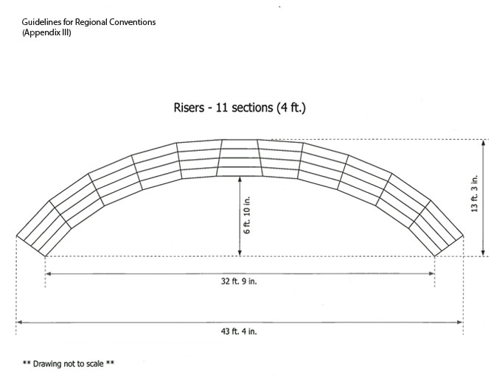

Please note that this configuration will accommodate all choruses in the region.

