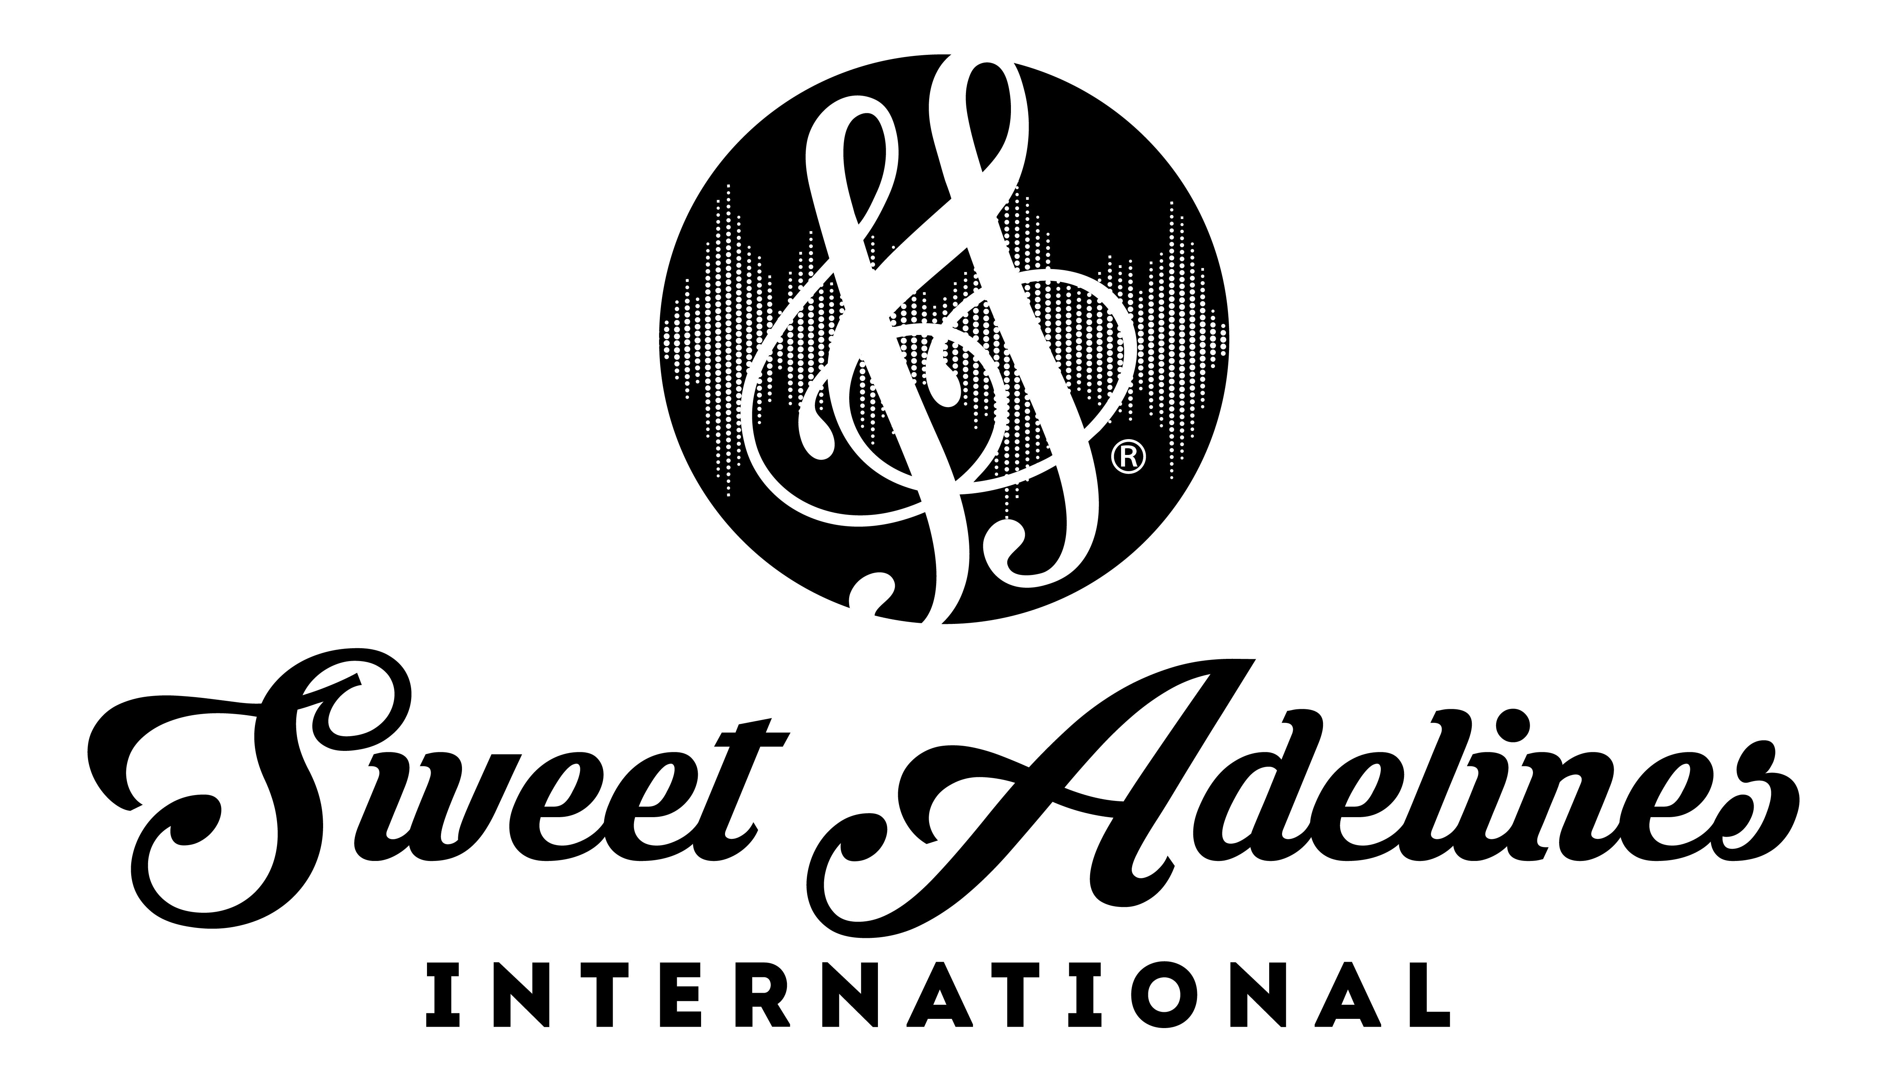

Region #17| Regional Competition | May 17-19, 2019 | Cleveland, Ohio
Quartet Order of Appearance

OAP # Quartet Chapter(s)

- CALM Pride of Toledo, CAL Region 17

- Swingularity Greater Cleveland,
Lake Ridge Legacy

- Surefire River Raisin, Greater Harmony, Battle Creek

- Ladies First Buffalo Gateway

- Ring True Lake Ridge Legacy

6. Sublime Fenton Lakes, River Bend,
Grand Rapids, CAL Region 17

7. Lucille Scottsdale, CAL Region 17,
Harborlites, CAL Region 15

8. Stand By Me Pride of Toledo, Little River

9. Party Favors Voices in Harmony

10. Resolution Lake Ridge Legacy

11. Fast Forward Allegheny Sounds,
CAL Region 17, Flagship City

12. Cadenza City of Flags

13. Wicked Greater Harmony,
CAL Region 17

14. Sticky Notes Grand Rapids

15. Note To Self Scioto Valley, Little River,
Pride of Toledo

(Page 1 of 2)

OAP # Quartet Chapter(s)

16. Shimmertones Little River

17. Stay Tuned! Buffalo Gateway

WWW.SWEETADELINES.COM

