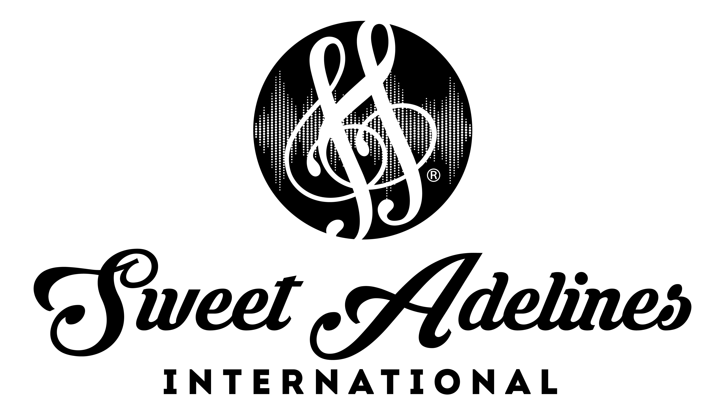

Region #17| Regional Competition | May 17-19, 2019 | Cleveland, Ohio
Chorus Order of Appearance

OAP # Chapter/Chorus Location Director(s)

- Coldwater Sweet Adelines, Coldwater, MI Josephine Wixson
EVALUATION

2 Sounds of Pittsburgh, Pittsburgh, PA David Wallace
EVALUATION

3. Lake Effect Harmony Boston, NY Sonne Durphy,
Susan Gentile

4. Voices in Harmony Yspilanti, MI Jennifer Jones

5. Pride of Toledo Toledo, OH Kay Seymour

6. Greater Harmony Pittsburgh, PA Michael Hengelsberg

- Dogwood Blossoms Mount Vernon, OH Donna Dudgeon

8. Laurel Harmony Greensburg, PA Vicky Westley

9. River Raisin Monroe, MI Dawn Seigneur

10. City of Flags Canton, OH Jay Dougherty

11. Buffalo Gateway Buffalo, NY Diane Porsch

12. Indi-Anna Indiana, PA Mary Lou McKinney

13. Maple Mountain Mentor, OH Pamela Dickinson

14. Battle Creek Battle Creek, MI Lynne Pierce

15. Lake Ridge Legacy Elyria, OH Dave Smotzer

16. Little River Angola, IN Betsy Fowler

17. Grand Rapids, Grand Rapids, MI Denise Van Dyken
OPEN DIVISION

WWW.SWEETADELINES.COM

