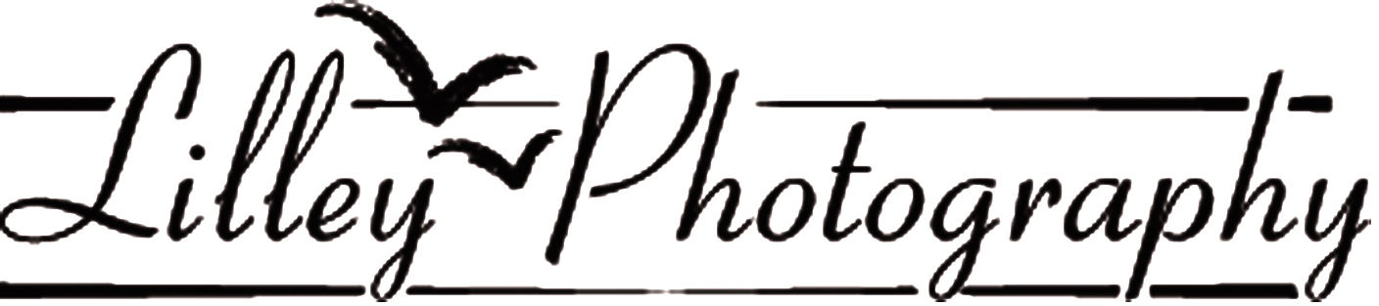
2019 Regional Quartet Photography Order Form

Region Quartet Name Costume Description .
Contact Name Mail Address
City ST/Prov Zip/PC
Day Phone email .
must know how to download jpeg image file from website. Very important to PRINT your email CLEARLY
Photo Order: Please indicate total number of each print size you want.

The minimum order is at least $32
If you don’t want any copies you still need to be photographed for Regional Use.

Special Q Package: 4 prints (8x10 or 5x7) plus 4 wallets plus Hi-Res PR File all for $83

Package; ____8x10 __5x7 + 4 wallets + Hi-Res Publicity File @$81 =_________
For example 8x10 each $17.00 =$ ________
2 8x10 Plus 2 5x7 5x7 each $15.00 =$
4x5 each $7.00 =$
Wallets each $4.00 =$
Publicity File will be mailed to you @ $20.00 =$
Shipping =$7.00
Grand Total = $
You may pay with Paypal, check (Please no Canadian checks), cash or credit card. Bring this form filled in with payment to the QUARTET BRIEFING ON FRIDAY. If paying by credit card please fill in the information below.

Card # Exp Date CVC
If the credit card does not belong to the person named as the contact above, I need the HOLDERS’S name, street address, zip/pc code as well as the CVC code on back of the card.
Name Street Address

Zip/PC Code CVC#
E. R. Lilley Photography 820 Rt. 28, Harwich Port, MA 02646
508-432-2266 Email: erlphoto@comcast.net.
Pose Ideas: port77.com/erlilleyphoto.com/poses

