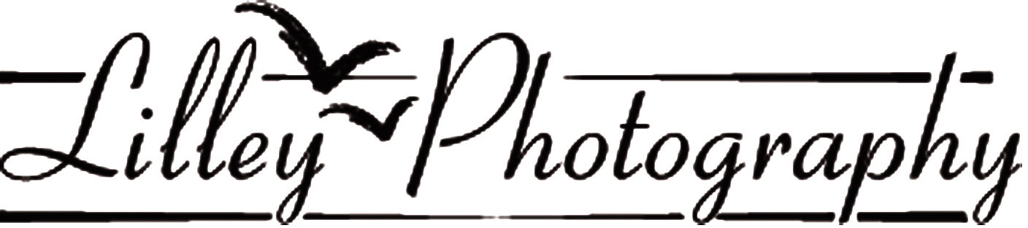

2019 INDIVIDUAL ORDER FORM FOR CHORUS PHOTOGRAPHS

Chairman! Do not give this to the photographer. It is for your use ONLY.

At the Regional Competition Lilley Photography will be photographing your chorus. To obtain copies of this photo please read the information below and fill out this order form. Please hand the bottom portion of this form to your Chorus Photo Chairperson by the cutoff date along with payment in full.

If you are not satisfied with your photos, for any reason, please return them within 30 days
to the photographer for a full refund.

Sizes Available
Small: 4x6 – Wallet (2.5x3.5) Large: 8x18 – 8x16 – 8x14 – 8x12 – 8x10 – 5X7

CHORUS SIZE SELECTION TABLE is for Normal “Tight” Poses. If you are using a spread out pose or have arms extended up or outside of the chorus, the next biggest size might be preferable. ALSO please use common sense. A group of 24 won’t fit on an 8x18
8x10 is suggested for choruses up to 30 members On stage
8x12 “ “ “ “ “ 40 “ “
8x14 “ “ “ “ “ 50 “ “
8x16 “ “ “ “ “ 60 “ “
8x18 “ “ “ over “ 70 “ “

INDIVIDUAL ORDER FORM
Please return this portion to your Chorus Photo Chairperson with
Cash OR check payable to the chorus BY Cuttoff date of ________________________

Name___________________________________ Phone#________________________________________
Please indicate how many copies of the sizes listed below you would like to order.

______8x18 @ US$22.00 = $________ ______8x10 @ US$17 = $_______

_____8x16 @ US$20.50 = $________ _____5x7 @ US$15 = $_______

_____8x14 @ US$19.50 = $________ ______4x6 @ US$7 = $_______

______8x12 @ US$18.00 = $________ ______Wall @ US$4 = $_______

Total Order = US$____________
Make check payable to chorus

Questions? Telephone 508-432-2266 or email: erlphoto@comcast.net
Monday thru Friday, 10 to 5 Eastern Time

