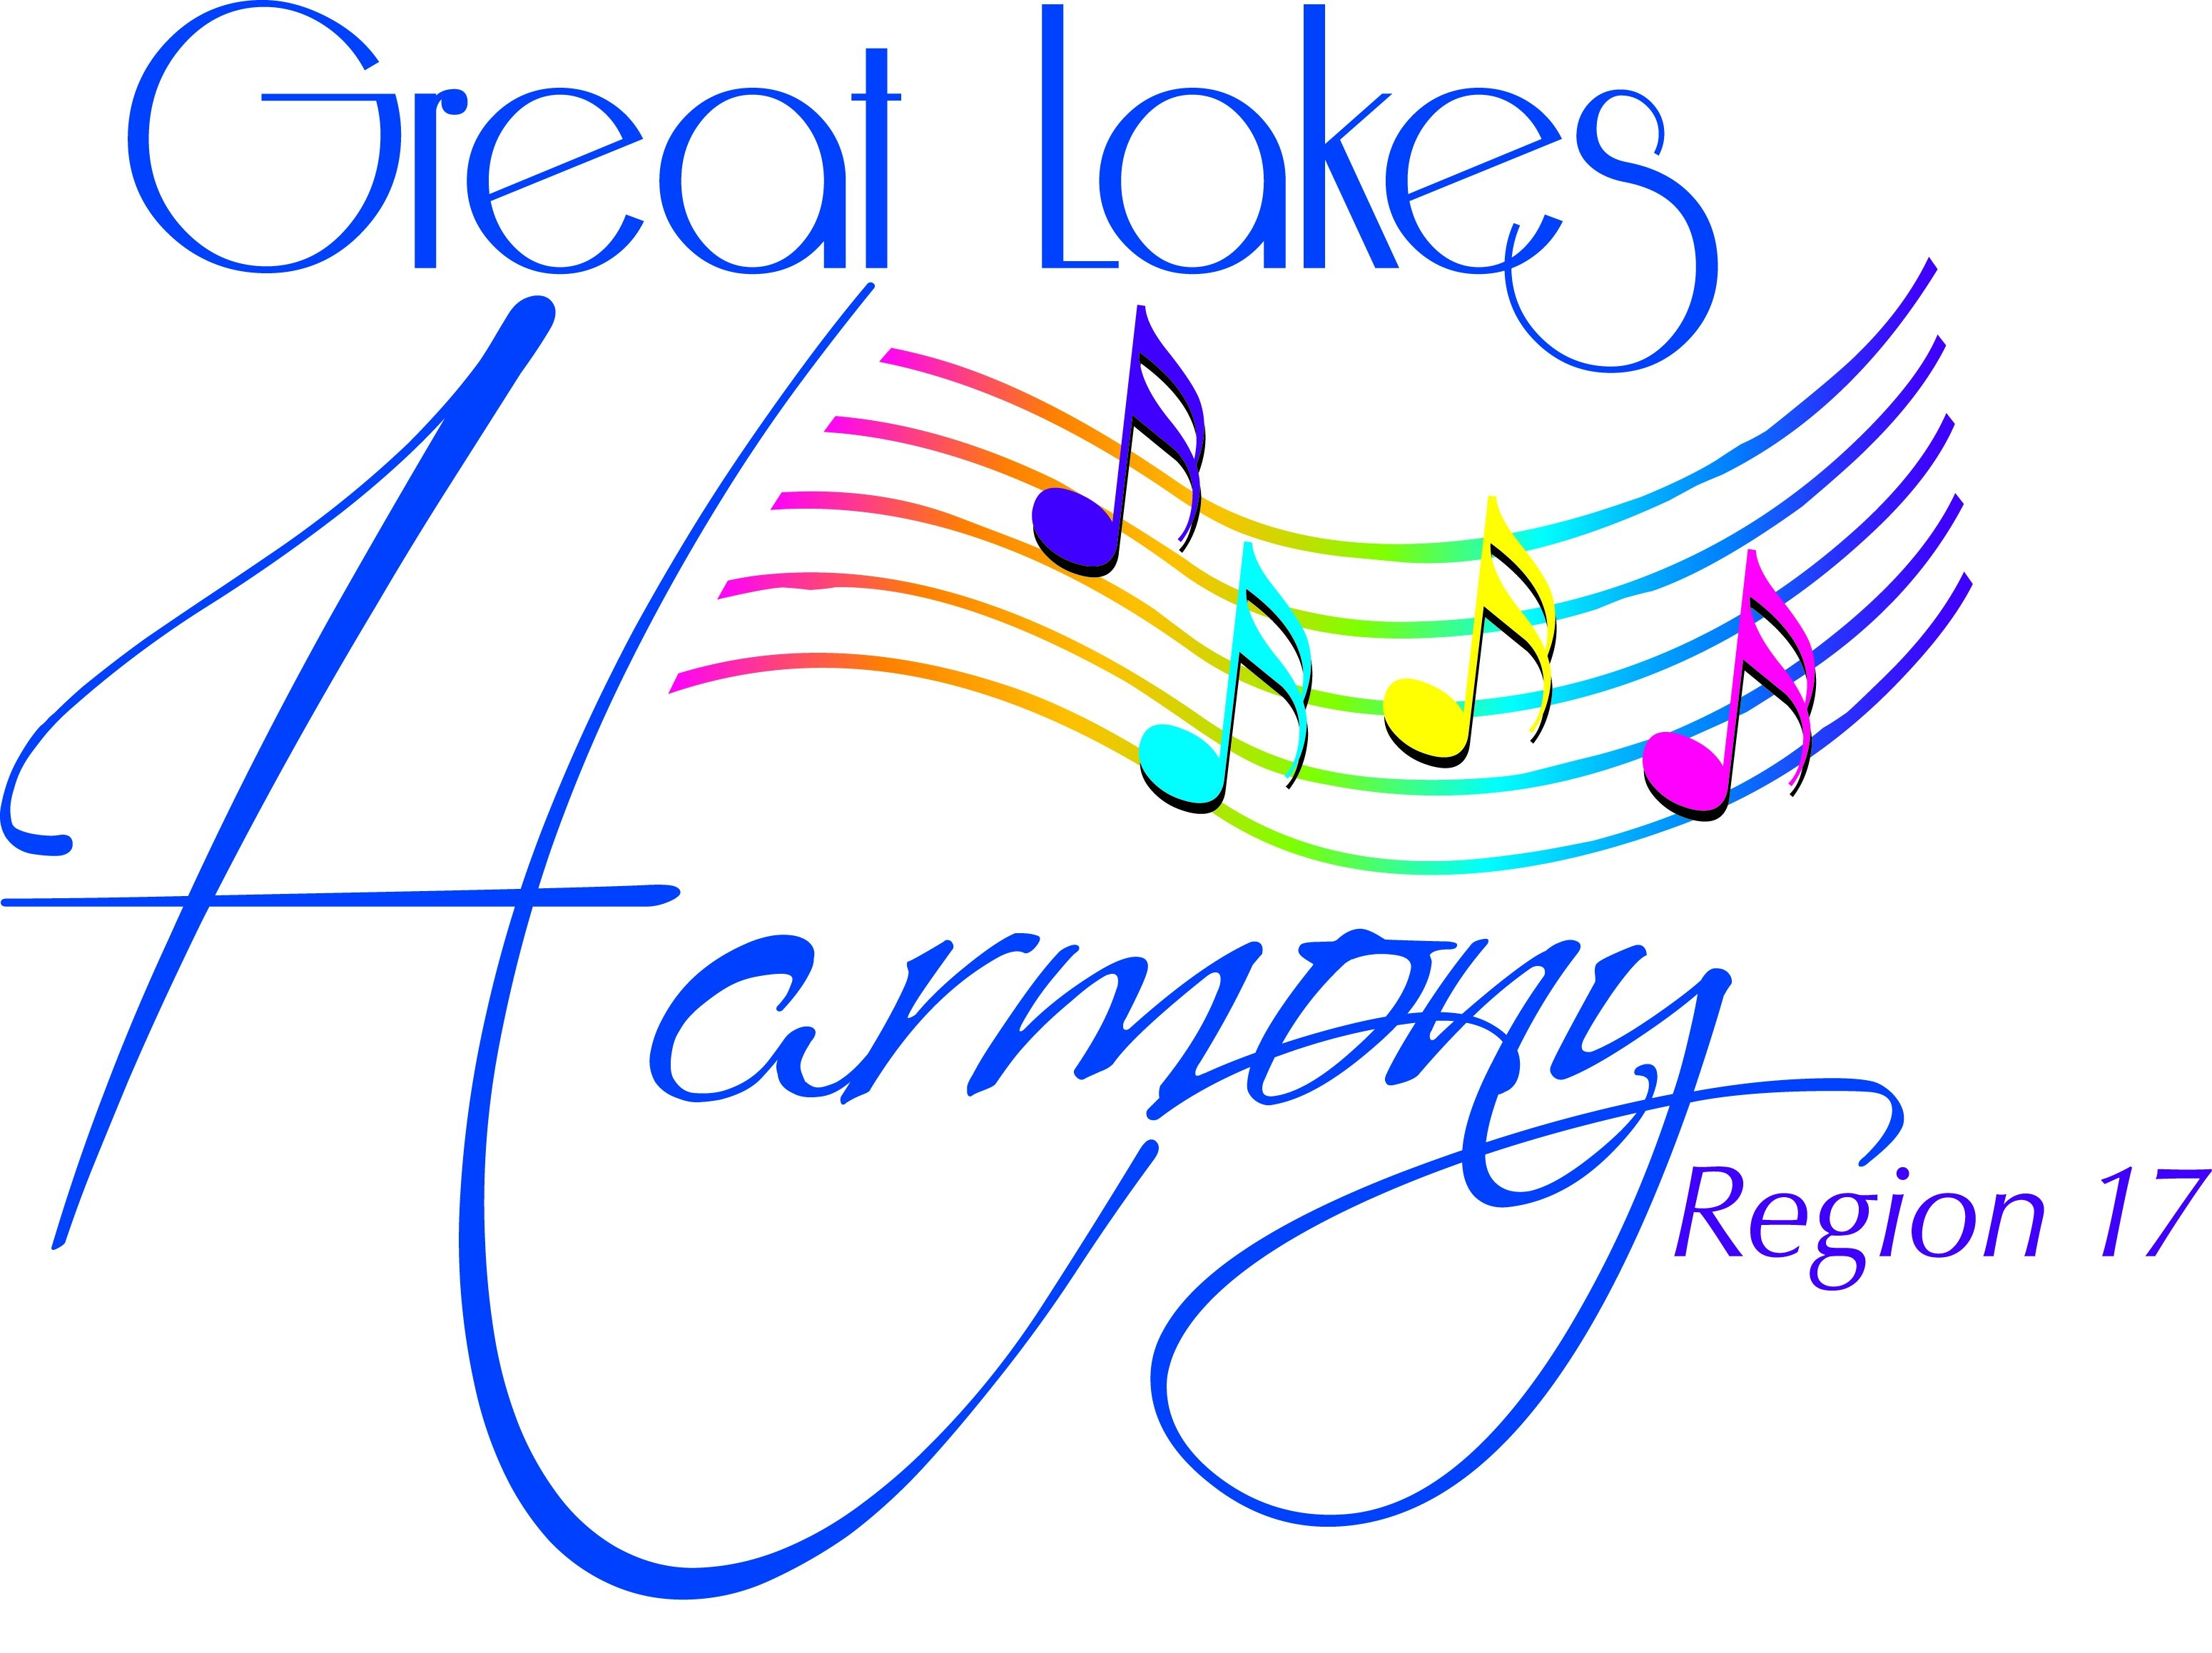
Great Lakes Region#17
WINTER HARMONY WEEKEND
Longevity Recognitions
Luncheon Menu:
February 4, 2017

Apple Chicken
Rice, Broccoli, Cauliflower, Carrots & Sugar Snap Peas
Rolls & Butter
Coffee, Iced Tea
Dessert

Luncheon is limited, so don't delay

Please use credit card or write one chapter check payable to:

GREAT LAKES HARMONY REGION #17

DEADLINE for luncheon reservations – Jan 28, 2017

Designated person will pick up all luncheon tickets at the Sweet Adeline registration
Table prior to luncheon and distribute to her fellow chorus members.

Luncheon tickets are non-refundable. They may be sold to another person.
Price includes Tax and Gratuity.

CHORUS NAME
NUMBER OF RESERVATIONS |  |  |  |  |  |  | @ $17/ea. = $ |  |  |  |  | enclosed
CONTACT PERSON
PHONE |  |  |  |  |  | EMAIL

Credit Card #

Ex. Date

Code on back

If sending Sue Heck If sending via email send to:
Via mail: 5229 Dungannon Cr NW Cathy Dunlap
North Canton, OH 44720 cdunlap1969@gmail.com
330-936-4061

HARMONY WEEKEND LUNCHEON FEBRUARY 4, 2017
Luncheon Ticket Order Form, Cost: $17ea
Please list each person purchasing a luncheon ticket. If you believe someone should receive a complimentary ticket, please note "COMP" by her name. The Events Team will then confirm the eligibility of that person. If the person is not eligible for a complimentary ticket, payment will need to be made.
Please return this form to: cdunlap1969@gmail.com or mail to
Sue Heck
5229 Dungannon Cr NW
North Canton, OH 44720
Ph: 330-324-2391
CHAPTER NAME:
1. |  | 22.
2. |  | 23.
3. |  | 24.
4. |  | 25.
5. |  | 26.
6. |  | 27.
7. |  | 28.
8. |  | 29.
9. |  | 30.
10. |  | 31.
11. |  | 32.
12. |  | 33.
13. |  | 34.
14. |  | 35.
15. |  | 36.
16. |  | 37.
17. |  | 38.
18. |  | 39.
19. |  | 40.
20. |  | 41.
21. |  | 42.

Please return no later than Jan. 28, 2017

