

Sweet Adelines International
Great Lakes Harmony Region 17

41st Annual Convention and Competition
April 27-30, 2017

Competition and Convention Informational Bulletin

Renaissance Hotel
Cleveland, Ohio

Volunteer Assistance Chorus
Grand Rapids

CRC – Karen Parsons • CC – Sue Heck
2017 Convention Committee Members

Name | Chapter Affiliation | Contact information
Laura Covell | Greater Harmony | 2826 Coblentz Dr., Poland, OH 44514
Official Panel Liaison |  | (H) 330-757-4174 (C) 330-506-6605
 |  | hywyr@zoominternet.net
Cathy Dunlap | City of Flags | 4746 Helmsworth Dr. NE, Canton, OH 44714
Awards/Banquet Services |  | (C) 330-936-4061
(RMT-Events Coordinator) |  | Cdunlap1969@gmail.com
Deb Ferenc | Greater Cleveland | 6545 Tulip Trail, Independence, OH 44131
Public Relations/Charity |  | (H) 216-573-7357 (C) 216-287-0355
 |  | Debbersings@gmail.com
Karen Parsons | Greater Cleveland | 2493 Windy Hill Dr, Pepper Pike, OH 44124
CRC |  | (H) 440-461-1887 © 216-346-8122
 |  | pharmasing@yahoo.com
Sue Heck | City of Flags | 5229 Dungannon Circle NW, North Canton, OH 44720
CC |  | (C) 330-324-2391
 |  | suehck@yahoo.com
Judy Horn | CAL | 10821 St. Joe Road, Ft. Wayne, IN 46835
Housing |  | (C) 260-466-5120
 |  | Pridesingr@aol.com
Carolyn Macomber | Little River | PO Box 39, Fremont, Indiana 46737
AEBs & Boutique |  | 260-668-5112
 |  | carolynmacomber@yahoo.com
Michelle Riggi-Smith | Greater Harmony | 799 Moon Ridge Dr., Freedom, PA 15042
Bulletins/Programs |  | (H) 724-869-5428 (C) 412-965-9265
 |  | msmith15042@comcast.net
Sharon Coe | Pride of Toledo | 3152 Kenwood Blvd, Toledo, OH 43606
Treasurer |  | (C) 419-367-6806
 |  | readsmysteries@yahoo.com
Sherry Berkley | Grand Rapids | 19465 Haviland Dr., South Bend, IN 46637
VAC Co Chairman |  | (C) 574-876-6778 (H) 574-243-0288
 |  | sherrylead@gmail.com
Sue Hollar | Grand Rapids | 1038 Westmoreland Ave., Kalamazoo, MI 49006
VAC Co-Chairman |  | (C) 269-491-7848 (H) 269-343-7607
 |  | shollar956@gmail.com
Tentative Schedule of Events

Thursday, April 27 |  |  | Friday, April 28 (continued)
Boutique – Ambassador Rm | 3:00 pm - 7:00 pm |  | Encore Club Celebration | Immediately after Quartet Contest
Convention Committee Coordination Meeting | 7:00 pm - 8:00 pm |  | Chorus Gatherings / Rehearsals | After Quartet Contest in assigned rooms
Quartet Reception | 8:30 pm - 10:00 pm
 |  |  | Saturday, April 29
Friday, April 28 |  |  | Chorus Gatherings / Rehearsals | In assigned rooms
Boutique – Ambassador Rm | 9:00 am - 11:00 pm |  | AEB Pick Up | 9:00 am - 12:00 noon
AEB Pick Up (in boutique) | 10:00 am - 6:00 pm |  | Boutique | 9:00 am - 12:00 pm and  5:00 pm – 11:00 pm
Site Inspection  (Volunteer Chorus, all quartets - All are welcome**) | 9:45 am – Warmups 10:00 am - Sing |  | Ticket sales | 10:30 am – intermission
Joint Briefing (Competing Quartets & Chorus Directors/Presidents/ Team Leaders) | 11:30 am |  | Curtain Call | 11:45 am
Hotel Registration 5:45 pm | 4:00 pm |  | Chorus Contest | 12:00 pm
Ticket sales | 3:30 pm – intermission
Curtain Call | 4:15 pm |  | Sunday, April 30
Quartet Contest | 4:30 pm |  | Convention Committee  Wrap up Meeting | 9:00 am 11:00 am
** Everyone is invited to be a part of the Site Inspection Chorus on Friday, April 28, 2017, at 9:45 am. Take part in warmups led by one of Region 17’s championship directors and sing your heart out on our stage.

PLEASE NOTE:
The CELEBRATION OF CHAMPIONS will take place at the September Harmony Weekend.
Invited to perform will be Choruses and quartets placing 1st – 3rd.

Important Deadlines

February 27, 2017 Quartet Entry due to International
February 28, 2017 Chorus Entry due to International
March 6, 2017 Order of Appearance Draw
March 14, 2017 Late Entry – Quartet due to International
March 15, 2017 Late Entry – Chorus due to International
March 10, 2017 Love Notes due to Michelle Riggi-Smith
March 25, 2017 Flash Drive forms due to Sue Heck
March 25, 2017 Housing Forms due to Judy Horn
March 25, 2017 AEB and VIP Seating Forms and Payment due to Carolyn Macomber
April 1, 2017 PR Permission forms due to Deb Ferenc
April 1, 2017 Billboard Ads due to Michelle Riggi-Smith
April 1, 2017 Competition song form due to Karen Parsons
Convention Charity

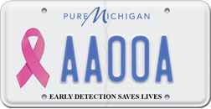
This year Region 17 Convention Committee has again chosen Breast Cancer as our Convention Charity. We continue to champion the breast cancer cause, and helping women and men on the grass roots level, this year we reach out to Michigan and Indiana this year. We have partnered with organizations in each of these states that are also raising funds through the sale of breast cancer awareness license plates. Please choose which state you would prefer to support and make your checks out accordingly.
The mission of the Indiana Breast Cancer Awareness Trust is to increase awareness and improve access to breast cancer screening and diagnosis throughout Indiana. Proceeds have funded over 16,000 mammograms for Hoosier women.
If you are an Indiana resident, I urge you to purchase the Indiana Hope license plate in support of this great organization. Visit their website www.breastcancerplate.org
Donations can be made several ways:
- For Indiana donations:
  - Make checks out to Indiana Breast Cancer Awareness Trust (IBCAT)

- For Michigan donations:
  - Make checks out to State of Michigan
  - Write this on each check: Index 71100\pca80503

- We urge chapters to continue to “fill the piggy banks” that were distributed a few years ago at Harmony Weekend for the October –Breast Cancer Awareness Month campaign. Convert your cash to a check made out to the State of your choice. Lost your piggy? Contact me, or improvise!!!!!
- Checks made out to State/Agency of your choice above and mailed to:
Deb Ferenc
6545 Tulip Trail
Independence, OH 44131
- OR, Bring your check to competition and turn it in at registration or give to Deb Ferenc!
The Region 17 Convention Committee feels that we will reach out to individuals in need on a much more personal level by supporting these very worthy organizations.
Please feel free to contact me with any questions you may have regarding these marvelous charities and visit their websites to learn more!
Thank you in advance for your generosity.
Deb Ferenc
Convention Committee
Quartet Video Taping Permission Form

Attn: All Competing Quartets

From: Ed & Deb Ferenc
Region 17 Convention Committee PR

Re: Permission to video during Quartet Pattern

In an effort to further promote our contest, we would like to invite the Media to film during our pattern on Friday evening. In order to do this, we need your permission to videotape during that time. Please have a member of your quartet sign and date this form and send it back to me no later than April 1! Thank you! Mail it to:
Deb Ferenc, 6545 Tulip Trail, Independence, OH 44131 or simply fax to (216) 901-1601.

Thank you for your anticipated cooperation!

♪♪♪♪♪♪♪♪♪♪♪♪♪♪♪♪♪♪♪♪♪♪♪♪♪♪♪♪♪♪♪♪♪♪♪♪♪♪♪♪♪♪♪♪♪♪♪♪♪♪♪♪♪♪♪♪♪♪♪♪♪♪♪♪♪♪♪♪♪♪♪♪

Name of Competitor
You DO grant permission to videotape during pattern
You DO NOT grant permission to videotape during pattern
Signature |  |  |  |  | Date

Comments:
Quartet & Chorus Competition Songs

Please complete this form and email to Karen Parsons (pharmasing@yahoo.com) by April 1.

International Contest
Contestant Number
Quartet or Chorus Name

Contest Songs: Title & Arranger
1.
Arranged by:

2.
Arranged by:

Open Division
Contestant Number
Quartet or Chorus Name

Contest Song: Title & Arranger
1.
Arranged by:
Traffic Pattern

This pattern will be accessible for all and no alternate pattern will be needed as we will not be using stairs or escalator.

THIRD FLOOR
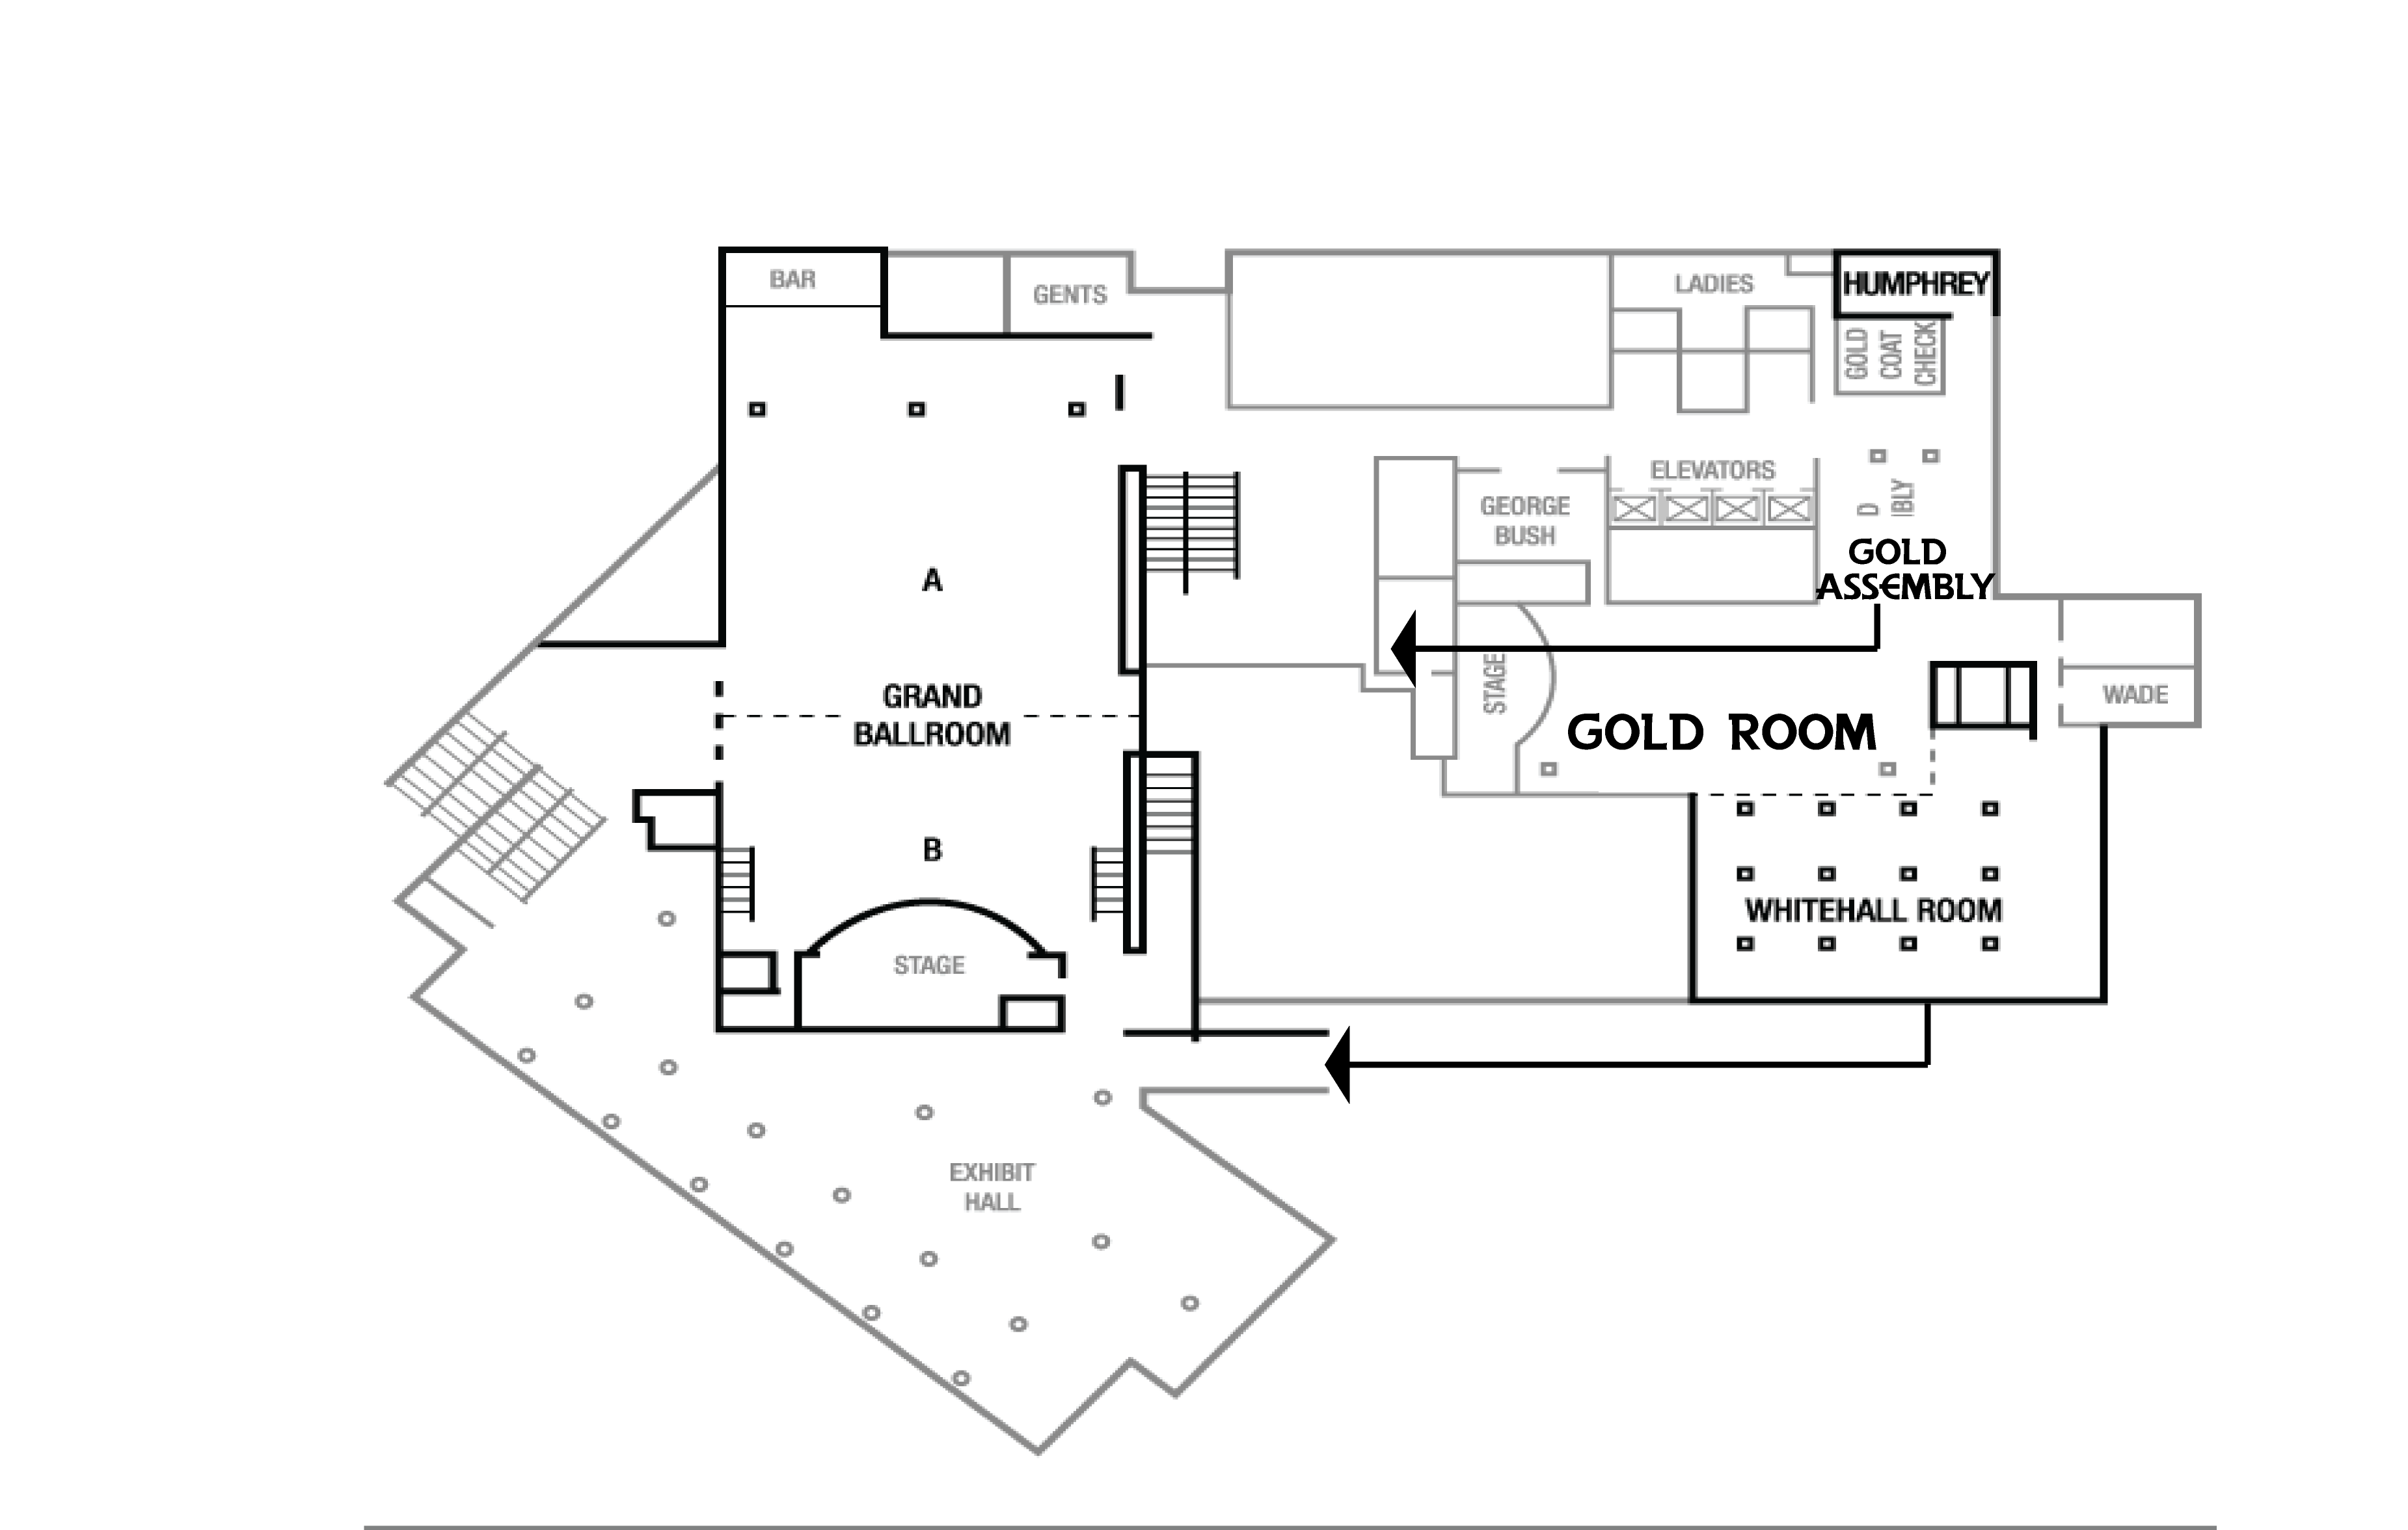
Contestants will assemble in the GOLD ASSMEBLY area.
All competitors will then be escorted through the Whitehall Room and the back hallway behind the kitchen to the Exhibit Hall.
Shhhhhh!
Note: there will be NO change in riser configuration. We will use the standard configuration with inverted center section.
Warmups will be in the GOLD ROOM. Quartets will have photos in the Whitehall Room.
Riser Configuration

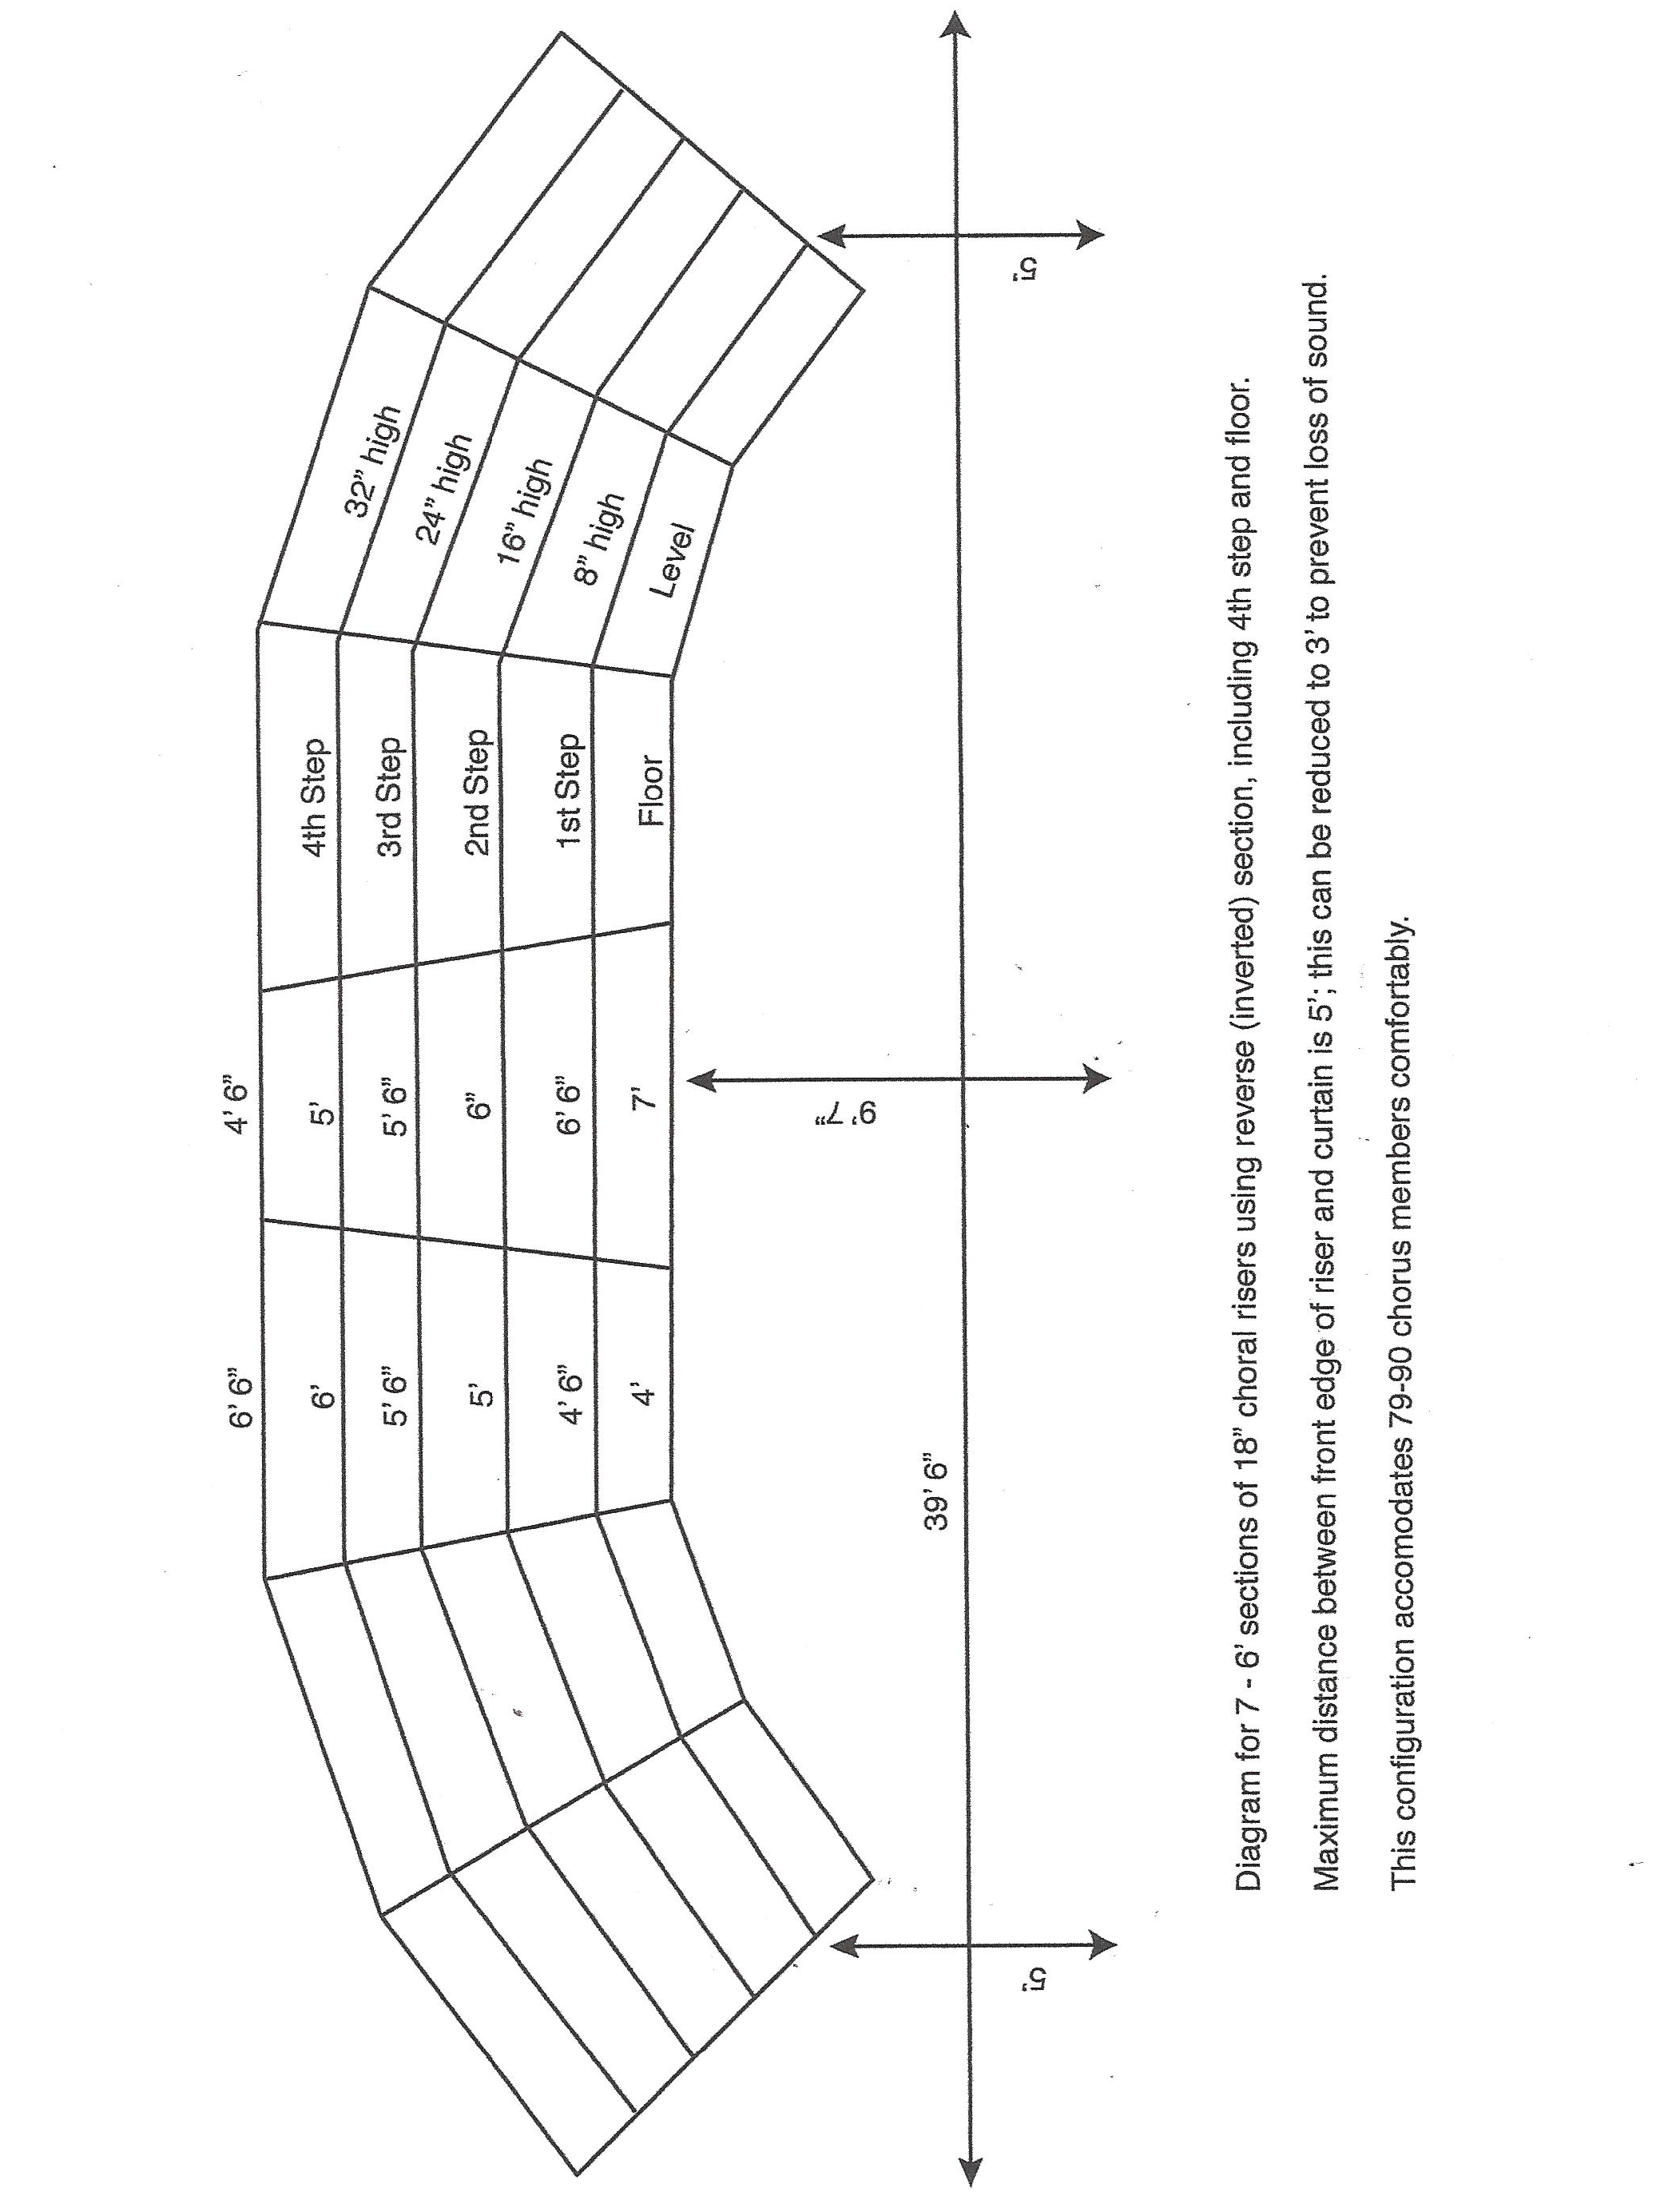
General Information

CONTEST ENTRIES:
Entry blanks are mailed out from International and are available online. A quartet or chorus whose entry blank is received at International Headquarters after the entry deadline date (60 days before the competition) is considered a late entry and is eligible to compete only if a late entry fee of $100 along with required entry fee ($100 for Quartets and $150 for Choruses) accompanies the entry blank. A contestant who is a late entry will sing at the beginning of the contest. Late entries will not be accepted after 45 days prior to the competition.

Quartet Entry Deadline----------------------------- February 27, 2017
Quartet Late Entry Deadline----------------------- March 14, 2017
Chorus Entry Deadline------------------------------ February 28, 2017
Chorus Late Entry Deadline------------------------- March 15, 2017

DRAWING FOR ORDER OF APPEARANCE IS MARCH 6, 2017
Rehearsal Schedules and Traffic Patterns are forwarded to Presidents, Directors, and Competing Quartets following notification of the Draw.

HANDICAP POLICY: If you have a member who requires special assistance, you will want to make certain that, either another chorus member, a family member, or a friend is available to help. You will need to provide a wheelchair if one is required. The Region is unable to provide wheelchairs. The Renaissance Hotel also has handicap rooms available. Please notify Pat Galvin immediately if there are any special needs.

PHOTOGRAPHY: The photographer will mail pricing information and order forms to competitors – or can be downloaded from the E.R. Lilley website. Quartet pictures will be taken in the Whitehall Room. Chorus pictures will be taken on stage.

PROGRAM PICK-UP PROCEDURE:
Programs will be distributed at the Renaissance Hotel, along with your AEBs. If you have any questions regarding programs, please contact Michelle Riggi-Smith.

PURSE SIZE RESTRICTION
A 3” x 5” cosmetic case or purse of the same size is the ONLY SIZE that will be accepted by your Hostesses. Anything larger will not be accepted and that member may have to carry it through the pattern herself.
Judging Panel ̶̶ 2017 Region 17 Competition

Sound: | Joan Boutilier – Region 03  Lake Zurich, IL |  | Music: | Jan Meyer - Region 09  Noblesville, IL
Expression: | Karen Sweeters – Region 01  Norwalk, CT |  | Showmanship: | Renee Porzel** - Region 03  Arlington Heights, IL
 |  |  |  | **indicates Panel Chair
Panel S  ecretary: | Marilyn Cox – Region 08  Colorado Springs, CO

AWARDS/UPDATES/CHANGES
Only those awards designated by the International Organization (i.e., placements 1-5, the Small and Mid-Size Chorus Awards and Most Improved Chorus Award) may be announced or presented within the framework of the Regional Quartet and Chorus competitions.
The second place chorus in a regional competition will be invited to compete in the international competition if the first-place chorus in the region is unable or chooses not to compete in the international competition for which it qualifies.
ALL MUSIC MUST HAVE CLEARED THE COPYRIGHT PROCESS. Failure to use cleared arrangements may result in disqualification. International headquarters will be responsible for administering the copyright policies and procedures. Please refer all questions and/or comments to Carol Schwartz, Director of Music Services, for handling. Regional personnel will not deal with copyright issues onsite.
QUARTETS AND CHORUSES COMPETING FOR EVALUATION ONLY will perform at the beginning of the competition. The emcee will announce on introduction if the competitor is performing for evaluation only.
CONTESTANT NUMBERING starts with one (1) and runs consecutively from the beginning to the end of the competition. Letters are used to designate late entries.
CHORUS DIRECTORS, PRESIDENTS, QUARTETS - Please be aware that, if withdrawal is necessary a written withdrawal notice must be received at international headquarters. A phone call is not considered official.
THE MOST IMPROVED CHORUS AWARD is presented to the Chorus which shows the greatest increase in total points over the preceding year’s competition.
ELIGIBILITY AND MID-SIZE AND SMALL CHORUS AWARDS – The number for determining eligibility for this award includes all performers on stage at any given time (not including the director). The number turned in at the directors’ briefing is used by the panel secretary to determine which choruses meet the mid-size and small chorus category criteria. The mid-size chorus has 31 to 60 performers on stage. The small chorus has 15 to 30 performers on stage. Both categories must score 400 or more points to be eligible.
1st Place Mid-Size Chorus Award Medals, sponsored by our Region, will be presented to all performers of the 1st place mid-size chorus at regional competition each year, including the director.

REGIONAL AWARDS

Regional awards may not be announced or presented within the framework of the Regional competition. All Regional Competition Awards will be presented after the final performance of the first place chorus.

Glitz Standard Of Excellence Award
The purpose of this award is to honor the most improved regional quartet at regional competition each year. The recipient quartet must have scored at least 400 points in order to be eligible for the award. The award will be presented for total overall improved score from the previous year. This traveling award may be won by the same quartet at the next competition. This award is donated by Glitz and will be presented by all or part of Glitz.

Live Wire Star Performer Award For Quartets
The purpose of this award, which consists of four (4) charms (one for each member of the quartet), is to recognize and honor the quartet having the highest score in Showmanship at the annual Regional Quartet Competition. If a tie score occurs in the Showmanship score between contestants, the contestant receiving the highest score in the Music category shall receive the award. If a tie still exists, this procedure shall be followed through the categories of Sound and Expression until the tie is broken. This award has been donated by Live Wire, and will be presented by all or part of Live Wire.

Novice Director Award
The purpose of this award is to honor a Novice Director directing a chorus for the FIRST time at a regional Sweet Adelines International or BHS competition. The award will go to the Novice Director of the chorus placing the highest in the competition with at least 400 points. The plaque will remain in the permanent possession of the recipient. This award is donated by Sounds of Pittsburgh Chorus.

Novice Quartet Award
The purpose of this trophy is to honor the highest scoring Novice Quartet of Great Lakes Harmony Region #17 each year. Novice is defined as no more than two (2) members having competed together or separately, in any previous Regional or International Competition. This award is donated by “The 4th Edition.”

Open Division Quartet Audience Choice Award
The purpose of this award, which consists of four medals, is to recognize and honor the quartet who was selected by the audience to receive the audience choice award. This award has been sponsored by Sidekicks Quartet and will be presented by all or part of Sidekicks. Should there be only one contestant in the quartet open division, the Bravo award will be presented to that quartet.
Love Notes

Deadline for Submission is March 10, 2017

This is a section designed just for you, the chorus or quartet member, to send your love to your friends and family for a mere $5.00! These love notes will be featured on a special page in the Regional Convention/Competition Program. Just print or type your special 60-character message and mail it with your payment to the address below. Get the whole chorus involved!!! It’s even available to be used by friends and family so they can send their love to YOU!
PLEASE: NO BUSINESS ADVERTISEMENTS.
Use the regular program ad form for chorus, quartet, and business ads.

Here are a few samples to give you some ideas:
Sally Singer - break a lip!!

What a BARI!!! Love, Mary P.

To my chorus – Give it your best shot!
Dolly Director

Go for it, MOM! We’re so proud of you!
Jen, Jim, John, & Sue

Ruthie Rookie – welcome to our chorus!

ABC chorus sends best wishes to all competitors

Love notes MUST be limited to 60 characters – which includes spaces and punctuation. If message is over 60 characters you will be asked to pay an additional $5.00. For larger love notes, please refer to advertising forms that follow.

Love notes are $5.00 each. Please make check payable to Great Lakes Harmony Region #17 – and mail or e-mail to:

Michelle Riggi-Smith Email: msmith15042@comcast.net
799 Moon Ridge Drive DEADLINE: March 10, 2017
Freedom, PA 15042

If you are e-mailing your request for a love note, please include “Love Note” in the subject line of your e-mail, the name on the check, and your check number.
Flash Drive Order Form

A Flash Drive of your performances will be available for purchase. If you would like to purchase a Flash Drive of your chorus or quartet for $5.00, please fill out this form and send with a check for $5.00 by March 25, 2017 to:

Sue Heck, 5229 Dungannon Circle NW, North Canton, OH 44720

Orders MUST be ordered and paid for advance by March 25, 2017. Otherwise, there will be no Flash Drive recording of your quartet/chorus performance.

Flash Drives will be immediately available and included in your packet with your score sheets. All performances will also be available in the Drop Box.

~~~~~~~~~~~~~~~~~~~~~~~~~~~~~~~~~~~~~~~~~~~~~~~~~~~~~~~~~~~~~~~~~~~~~~~~~~~~~~~~~~~

FLASH DRIVE ORDER FORM

Quartet/Chorus Name:
Contact Person
E-MAIL: |  | PHONE

$5.00 Enclosed | Check ______ |  | Cash ______

Due to copyright laws, performances cannot be reproduced on YouTube or social media without permission from Sweet Adelines International.

You can mail form with payment to Sue Heck, 5229 Dungannon Circle NW, North Canton, OH 44720.
AEB Information

We are pleased to announce that the Reservation (VIP) seating is being offered again this year, with advance sales only. VIP SEATING is not available after March 25, 2017. It is very important to stress that these seats are for badge holders only! Please ask your chapter members to observe this special seating.

If you meet the PUBLISHED DEADLINES, all AEBs will be available in the Boutique. If a chorus member is picking up AEBs for another/other member(s), she must sign for those taken. Thank you for your continued support and help.

*****Please remember to bring your lanyards and badge holder to insert your AEB.
You MUST have this for entry into all contest functions *****
BADGE PRICES ARE AS FOLLOWS:

VIP Seating AEB……………………………. $70.00
Member AEB…………………………….…. $50.00
Non-Member AEB……………..………… $60.00
(includes male directors)

There will be a $5.00 per AEB LATE FEE charged on AEB orders postmarked after March 25, 2017.

Orders postmarked after that date will NOT be processed until all late fees have been received!!!

(AN AEB IS NON-REFUNDABLE, BUT IT IS TRANSFERABLE)
The price of an All-Events Badges purchased after March 25, 2017

(Through the mail only) will be:

Member AEB………………………………….. $55.00
Non-Member AEB…………………………… $65.00
AEBs will NOT be sold at the Convention. We will also be selling SINGLE EVENT TICKETS ($40.00) and Student tickets ($10.00)* prior to and during the beginning of each event. And – we are now able to accept credit cards for any single event or student ticket* sold at the door.
If you have questions about All-Events Badges, please contact: Carolyn Macomber.
Phone: 260-668-5112 • Email: carolynmacomber@yahoo.com

*current student id required
All Events Badge Order Form

DEADLINE March 25, 2017

CHORUS NAME
CONTACT |  | PHONE
ADDRESS
CITY |  | STATE |  | ZIP
EMAIL ADDRESS

Total number of VIP seating AEBs |  | @ $70.00 = | $
Total number of member AEBs |  | @ $50.00 = | $
Total number of non-member AEBs |  | @ $60.00 = | $
Late fees (orders postmarked after 3/25) |  | @ $ 5.00 = | $
Number of complimentary AEBs |  | (for any convention committee members)  And 50+ members

TOTAL AMOUNT ENCLOSED: $

___ Check Enclosed  Make checks payable to:  Great Lakes Harmony Region #17 | ___ Credit Card (MC/VISA)  Credit Card #_________________________________  Name on Card: _______________________________  Exp. Date: ____________ CVV Code: ____________  Address for card holder (if different than above)  ___________________________________________  City: ________________ State ________ Zip:______
Mail this form and the excel name entry form to Carolyn Macomber: P.O. Box 39, Fremont, IN 46737
A $5.00 per AEB late fee will be charged on orders postmarked after March 25, 2017. AEBs are non-refundable, but they are transferable.
Renaissance Hotels

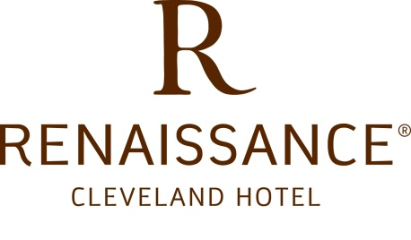
Every city has one premiere hotel that reflects its character, style and history. In Cleveland, that hotel is the Renaissance Cleveland Hotel. Opened in 1918, the hotel architecture is distinguished by craftsmanship of the early twentieth century. Upon entering, one senses the grandeur of the hotel as the Grand Staircase leads to the spacious Main Lobby where vaulted ceilings, high arched windows and marble fountain grace the comfortable and charming atmosphere. Guest rooms and suites are traditionally appointed furthering the sense of ease and comfort that one experiences upon arrival into the hotel. The Renaissance Cleveland Hotel continues to offer prime location for business or pleasure. In the heart of Cleveland's business, shopping and entertainment districts the hotel is also adjacent to the Rapid Transit System offering a direct link to the terminal at Cleveland Hopkins Intl Airport. The Renaissance Cleveland Hotel is the Grand Dame of the city - Cleveland's landmark social and business address.

STANDARD ROOM: 190 Square Feet (Rate: $133.00) Each one of our standard deluxe rooms feature either one queen bed, two queen beds or one king bed with luxury bedding (down comforters, cotton-rich linens and down pillows. Each room comes with the following:
- Chair, oversized with ottoman
- Clock Radio
- Safe, in room
- Desk, writing / work, with electrical outlet
- Iron and ironing board
- Air-conditioned
- Living/sitting area
- Windows may be opened

PARLOR SUITE: 630 Square Feet (Rate $164.00). This suite offers a parlor area with a sofa, coffee table and comfortable furniture, which is separate from a bedroom with one king size bed or two queen size beds. This suite does not have a dining room table or marble beverage area.

DELUXE SUITE: 900 Square Feet (Rate $266.00). This Suite faces north looking over the lake. This is a Deluxe Suite which is very spacious and elegant. It will offer a marble beverage area along with a dining room table with additional leaves, sofa, coffee table, desk and various comfortable chairs. This Suite has one king-size bed or two queen-size beds in a separate bedroom with a pocket door leading to the marbled bath to offer additional access and privacy from the parlor area.

WHIRLPOOL SUITE: 1,198 Square Feet (Rate $272.00). This is an elegant and spacious Deluxe Suite facing north looking over the lake. This Suite offers a marble beverage area, kitchen and half bath off of the living area as well as a dining room table with additional leaves, sofa, coffee table, desk and various comfortable chairs. This Suite has one king-size bed in a separate bedroom with a very large and impressive marbled bath. The bath offers a large tub with Jacuzzi jets.
Room & Tax Breakdown by Night and by Person
1 Queen Bedroom/2 Queen Bedroom - Rate $133.00
Number of Nights | 1 PERSON |  | 2 PEOPLE  (total per person) |  | 3 PEOPLE  (total per person) |  | 4 PEOPLE  (total per person)
1 night | ROOM RATE | $133.00 | ROOM RATE | $66.50 | ROOM RATE | $44.33 | ROOM RATE | $33.25
1 night | State Tax | $10.64 | State Tax | $5.32 | State Tax | $3.55 | State Tax | $2.66
1 night | City Tax | $3.99 | City Tax | $2.00 | City Tax | $1.33 | City Tax | $1.00
1 night | Tax | $7.32 | Occupancy Tax | $3.66 | Occupancy Tax | $2.44 | Occupancy Tax | $1.83
1 night | Total w/tax | $154.95 | Total w/tax | $77.47 | Total w/tax | $51.65 | Total w/tax | $38.74
1 night | Tax exempt | $144.31 | Tax exempt | $72.15 | Tax exempt | $48.10 |  | $36.08
2 nights | Total w/tax | $309.89 | Total w/tax | $154.95 | Total w/tax | $103.30 | Total w/tax | $77.47
2 nights | Tax Exempt | $288.61 | Tax Exempt total | $144.31 | Tax Exempt total | $96.20 | Tax Exempt total | $72.15
3 nights | Total w/tax | $464.84 | Total w/tax | $232.42 | Total w/tax | $154.94 | Total w/tax | $116.21
3 nights | Tax Exempt total | $432.92 | Tax Exempt total | $216.46 | Tax Exempt | $144.30 | Tax Exempt total | $108.23
Parlor Suite - $164.00
Number of Nights | 1 PERSON |  | 2 PEOPLE  (total per person) |  | 3 PEOPLE  (total per person) |  | 4 PEOPLE  (total per person)
1 night | ROOM RATE | $164.00 | ROOM RATE | $82.00 | ROOM RATE | $54.67 | ROOM RATE | $41.00
1 night | State Tax | $13.12 | State Tax | $6.56 | State Tax | $4.37 | State Tax | $3.28
1 night | City Tax | $4.92 | City Tax | $2.46 | City Tax | $1.64 | City Tax | $1.23
1 night | Tax | $9.02 | Occupancy Tax | $4.51 | Occupancy Tax | $3.01 | Occupancy Tax | $2.26
1 night | Total w/tax | $191.06 | Total w/tax | $95.53 | Total w/tax | $63.69 | Total w/tax | $47.77
1 night | Exempt | $177.94 | Total if exempt | $88.97 | Total if exempt | $5931 | Total if exempt | $44.49
2 nights | Total w/tax | $382.12 | Total w/tax | $191.06 | Total w/tax | $127.37 | Total w/tax | $95.53
2 nights | Tax Exempt total | $355.88 | Tax Exempt total | $177.94 | Tax Exempt total | $118.63 | Tax Exempt total | $88.97
3 nights | Total w/tax | $573.18 | Total w/tax | $286.59 | Total w/tax | $191.06 | Total w/tax | $143.30
3 nights | Exempt total | $533.82 | Exempt total | $266.91 | Exempt total | $177.94 | Exempt total | $133.46
Deluxe Suite - $266.00
Number of Nights | 1 PERSON |  | 2 PEOPLE  (total per person) |  | 3 PEOPLE  (total per person) |  | 4 PEOPLE  (total per person)
1 night | ROOM RATE | $266.00 | ROOM RATE | $133.00 | ROOM RATE | $88.67 | ROOM RATE | $66.50
1 night | State Tax | $21.28 | State Tax | $10.64 | State Tax | $7.09 | State Tax | $5.32
1 night | City Tax | $7.98 | City Tax | $3.99 | City Tax | $2.66 | City Tax | $2.00
1 night | Tax | $14.63 | Tax | $7.32 | Tax | $4.88 | Tax | $3.66
1 night | Total w/tax | $309.89 | Total w/tax | $154.95 | Total w/tax | $103.30 | Total w/tax | $77.47
1 night | Total if exempt | $288.61 | Total if exempt | $144.31 | Total if exempt | $96.20 | Total if exempt | $72.15
2 nights | Total w/tax | $619.78 | Total w/tax | $309.89 | Total w/tax | $206.59 | Total w/tax | $154.95
2 nights | Tax Exempt total | $577.22 | Tax Exempt total | $288.61 | Tax Exempt total | $192.41 | Tax Exempt total | $144.31
3 nights | Total w/tax | $928.67 | Total w/tax | $464.84 | Total w/tax | $309.89 | Total w/tax | $232.42
3 nights | Tax Exempt total | $865.83 | Tax Exempt total | $432.92 | Tax Exempt total | $288.61 | Tax Exempt total | $216.46

Housing Info

SEND COMPLETED FORMS TO:  Judy Horn  Email: Pridesingr@aol.com |  |  |  |  | DEADLINE FOR RESERVATIONATIONS  March 25, 2017
Chorus Name
Housing Chair
City |  |  |  |  |  |  | State |  |  |  |  |  |  | Zip
Phone (Day) |  |  |  | (Evening) |  |  |  |  |  | Email
HOTEL: Renaissance Cleveland Hotel |  |  |  |  |  |  |  | Tax Exempt y/n:
24 Public Square Cleveland, OH 44113 |  |  |  |  |  | Do Not Send Reservations To The Hotel  You must USE the 2017 HOUSING FORM

ONLY SUBMIT the housing FORM IN THIS PACKET. NO OTHER FORMS will be ACCEPTED. ONLY send pages that have been filled out. ALL FORMS to be SENT ELECTRONICALLY to pridesingr@aol.com

**CHORUSES PLEASE SEND YOUR EXEMPTION FORM WITH RESERVATION**
GUEST ROOM RATES: $133.00 - $272.00 (price is based on room type) per room per night plus 16.5% City/State/County Tax and sales tax.
All choruses who submit a tax-exempt form are exempt from the sales tax. TE Forms included at the end of this packet. The hotel has a limited number of roll-a-ways, please indicate below how many will be needed.
____________________________________________________________
If chorus is arriving by bus, list approximate time and date of arrival

CHECK IN TIME: 4:00pm CHECK OUT TIME: 12:00pm

METHOD OF PAYMENT: Bill will be paid by (X one of the following)
 | Chapter Check upon Check-In |  | Individual payment (cash/check/cc) upon Check-In
 | Chapter Check upon Check-Out |  | Individual payment (cash/check/cc) upon Check-Out
 | Full Advanced deposit payment (received within 15 days of Check-In)
 | Direct Bill (payment after event & paid within 30 days) |  |  | DB Acct # |  | (hotel use)

~CHORUS SUMMARY~
 | THURSDAY | FRIDAY | SATURDAY
Standard
Parlor Suite
Deluxe Suite
Whirlpool Suite
ROLLAWAY

THIS FORM MUST ACCOMPANY THE HOUSING FORM (EXCEL DOCUMENT) TO COMPLETE ROOMING LIST
Blanket Certificate of Exemption
PRESCRIBED BY THE TAX COMMISSIONER UNDER RULE NO. TX 1 1-03

The undersigned hereby claims exemption to purchases of tangible personal property from
NAME OF VENDOR | on and after
DATE

is based upon the purchaser’s proposed use of the items purchased, the activity of the purchaser, or both, as shown hereon:

Granted exemption from federal income tax as an IRS 501 (c)(3) charitable non-profit organization
__________________________________________________________
PURCHASER MUST STATE STATUTORY REASON FOR CLAIMING EXEMPTION OR EXCEPTION

This certificate shall continue in force until revoked and shall be considered a part of each order given to the above named vendor unless the ____________________________________________________
order specifies otherwise.

(Purchaser’s Name)
Women’s Singing Organization
(Purchaser’s Activity, i.e., Manufacturer, Public Utility, Church, etc.)
(Purchaser’s Address)
 |  |  |  | -Finance Coordinator
(By – Signature and Title)
(Date Signed)
N/A | Tax ID #
(Vendor’s License, if any)

Video Billboard Advertising

Deadline April 1, 2017

VIDEO BILLBOARD ADVERTISING!

Get your message out in living color to a captive audience as it scrolls by on two 9 X 12 screens in front of over 700 attendees. Before, during and after each contest session, your ad will project on the screen for all to see.

The Fundraiser rate of $50.00 is limited to Sweet Adelines International choruses, regions or quartets. You can advertise any upcoming shows or fundraising events; pay tribute to your chorus director, coach, or Sweet Adeline of the Year. What better way to get your message out to the convention attendees?

The Commercial rate of $100.00 applies to all for-profit businesses, including members and nonmembers. Get your request in early and receive $25.00 off if ad and payment are postmarked by April 1. Put your business message out there for all to see!

All ad copy must be 1024 x768 resolution format. Power Point is the preferred media, but .jpg is also acceptable. Ads should be submitted via e-mail, cd, or flash drive (non-returnable), before April 1, 2017. If e-mailing, please include “Region 17 ad submission” in the subject of your e-mail, and please include the name that will be on the check, and the check number to msmith15042@comcast.net.
~~~~~~~~~~~~~~~~~~~~~~~~~~~~~~~~~~~~~~~~~~~~~~~~~~~~~~~~~~~~~~~~~~~~~~~~~~~~~~~~~~~~~~~

Video Advertising Order Form
Name |  |  | Phone:
Address
City |  | State: |  |  |  | Zip:
Email:

Please check one:
Commercial ad |  | Early bird ad |  | Fundraiser ad

If you will be e-mailing your ad copy, please include “Region 17 ad submission” in the subject of your e-mail, and please include the name that will be on the check, and the check number to msmith15042@comcast.net. Or U.S. mail to:

Michelle Riggi-Smith
799 Moon Ridge Drive
Freedom, PA 15042

DEADLINE FOR ADVERTISING IS April 1, 2017

